##### “Small Table Calendar "

##### 

**Price: Rs.700/-**

These are cute small table Calendar for kids available in different colors.

We take great care in selecting our products. Pretty much everything we sell is sourced from East Asia, home to some of the world's best stationery. Korea and Japan in particular is where most of the stuff we offer is designed and manufactured.

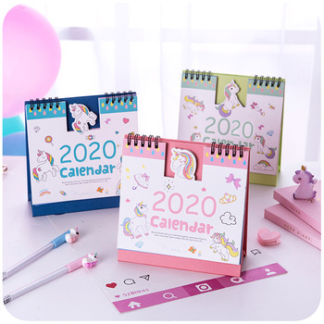

* Model Number: 20785856119
* Type: Calendar
* Promotional: No
* Style: Wooden
* Display Screen: show as the picture
* Use: Holders
* Origin: Japan
* Color: white, blue, black.
* Size: 6.5cm x 12cm x15cm
* Type: Wooden Calendar